**Lakpa Nurpu Sherpa**

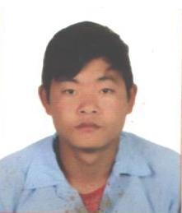Lakpa Nurpu Sherpa is one of the cheerful kid of Haku, Rasuwa. He is a bright student of class 10th, Shree Haku Secondary School. Lakpa lost his home in the devastating events of April’s earthquake. Which added more layers of trouble to his family. Lakpa has be raised in poor facilities yet he has dreams to achieve all he wants in his life. When we ask him how he will achieve so much. He says “Karma”. He believes if he supports his tendency to be educated, one day he will achieve everything through his skills.

Apart from being a bright student of his class, Lakpa is also a good athelete. He loves football and even living in a remote area, he manages to get updates of all his favorite matches. He wants to be a footballer and play for his country but due to lack of facilities and exposer he is unable to achieve his this dream. When we asked him about it he said “If not me, my kids will be proud football players of Nepal and I will provide them resource and facilities”.